Practical 5
Aim
To install and configure the AWS Command Line Interface (AWS CLI) and perform Amazon S3 operations such as creating, listing, uploading, and deleting buckets and objects using command-line commands.
Requirements
- AWS account
- Computer with Windows/Linux/macOS
- Internet connection
- AWS CLI
- AWS access credentials with appropriate S3 permissions
AWS Configuration
AWS Region: Asia Pacific (Mumbai) — ap-south-1
Procedure
1. Install AWS CLI
- Download and install the AWS CLI appropriate for the operating system.

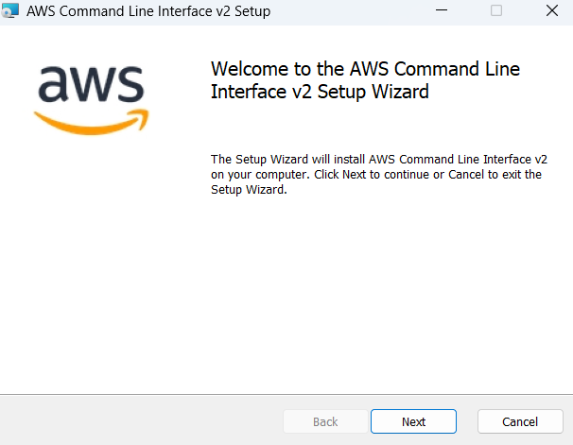

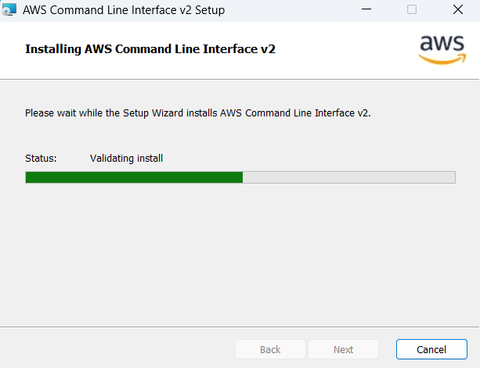
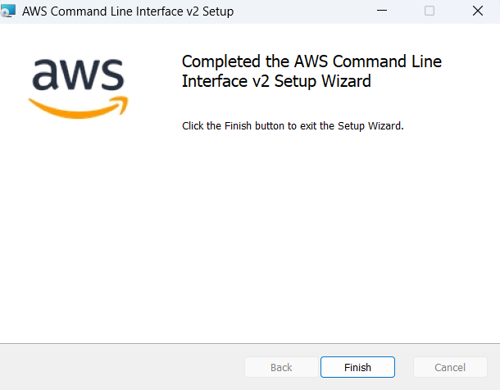
- After installation, open Command Prompt/PowerShell on Windows or a Terminal on Linux/macOS.
- Verify the installation using:
aws --version
- The command should display the installed AWS CLI version.
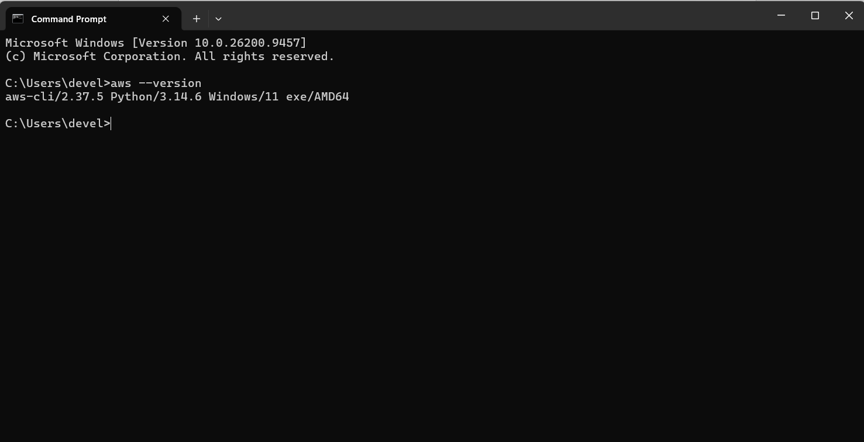
1.5. Configure AWS CLI Credentials
After installing the AWS CLI, configure it with the credentials of an authorized IAM user.
Procedure
- Sign in to the AWS Management Console.

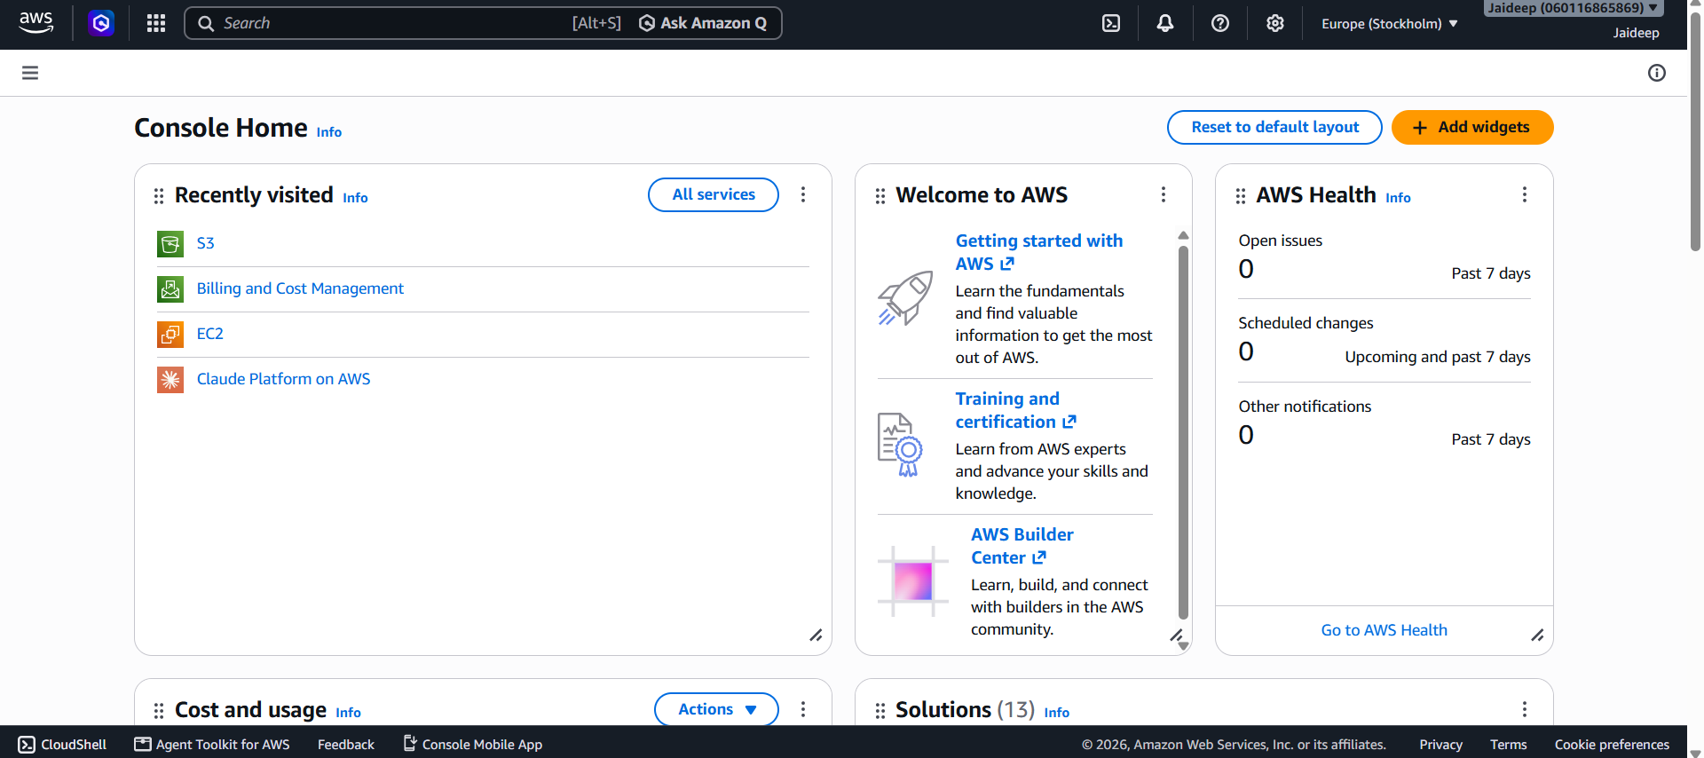
- Open IAM (Identity and Access Management).

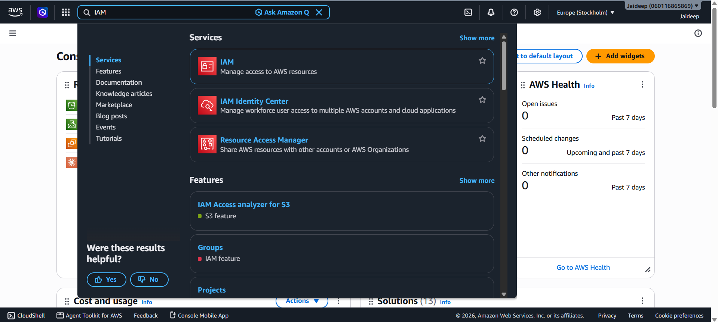
- Select Users and choose the IAM user to be used for CLI access.
(Create a new user if not yet created, by following the below steps.)

- 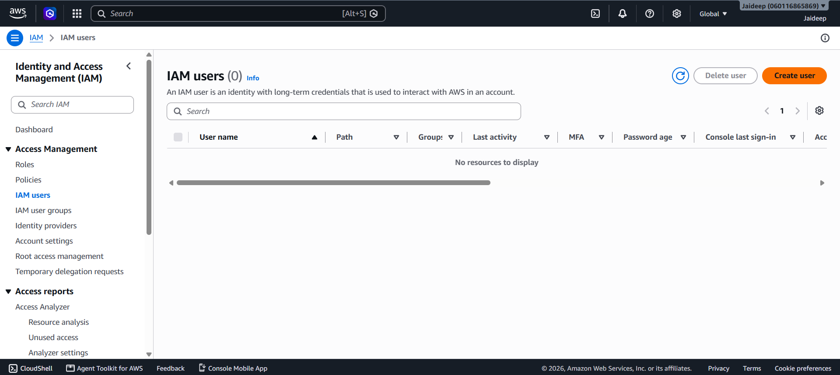

- 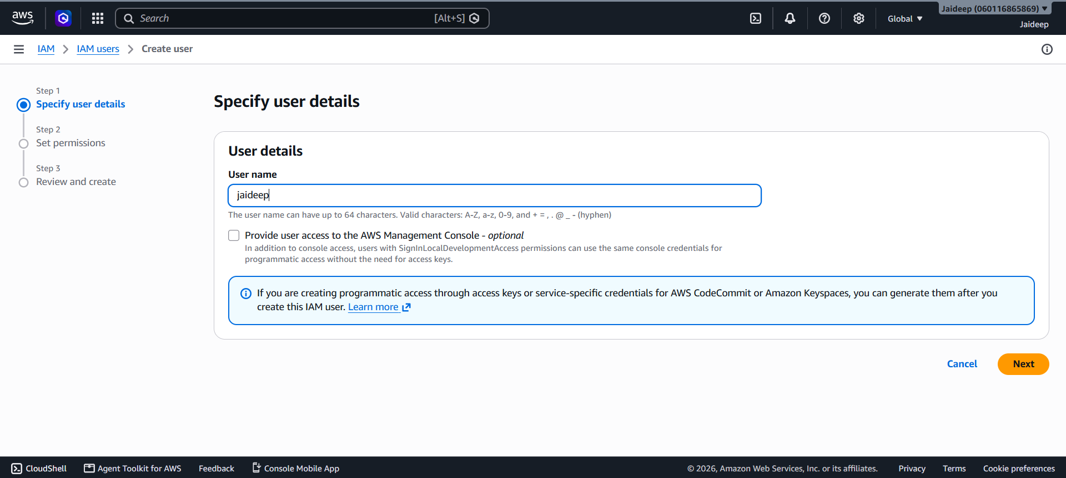

- 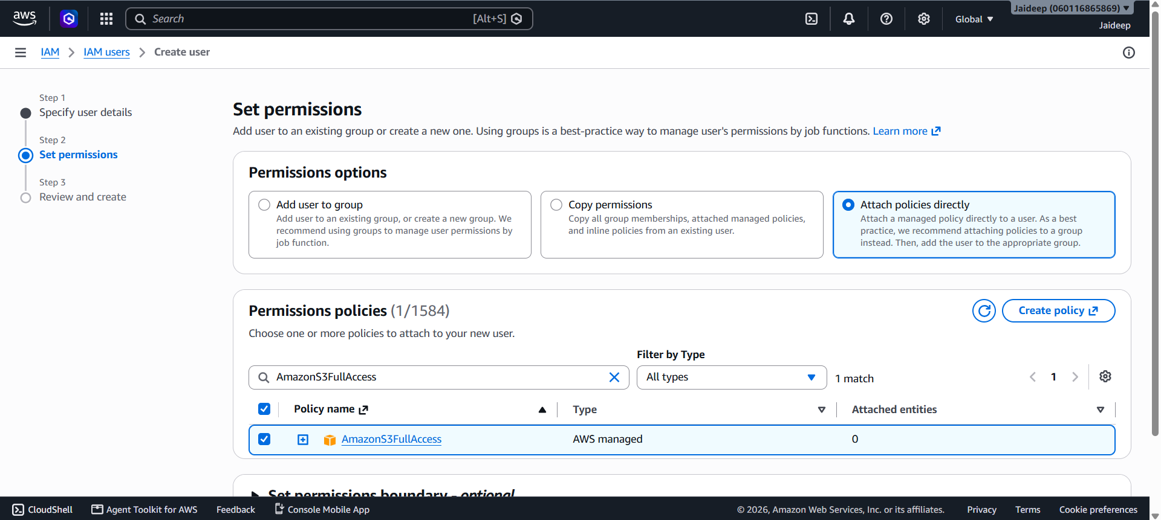

- 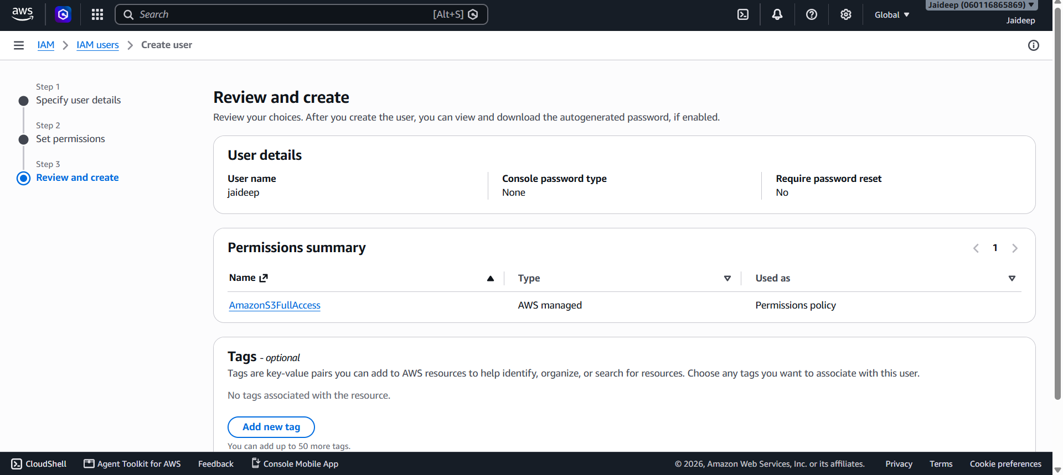
- 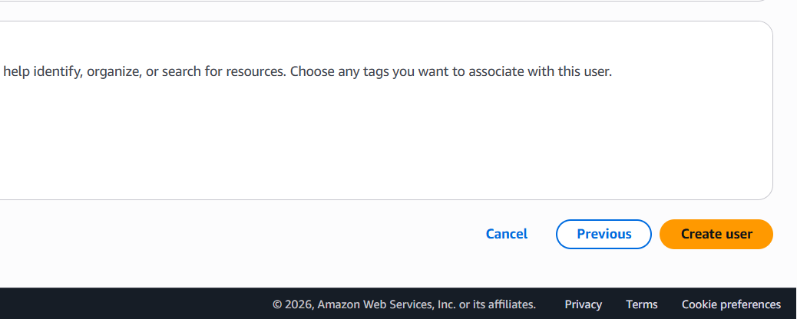

- 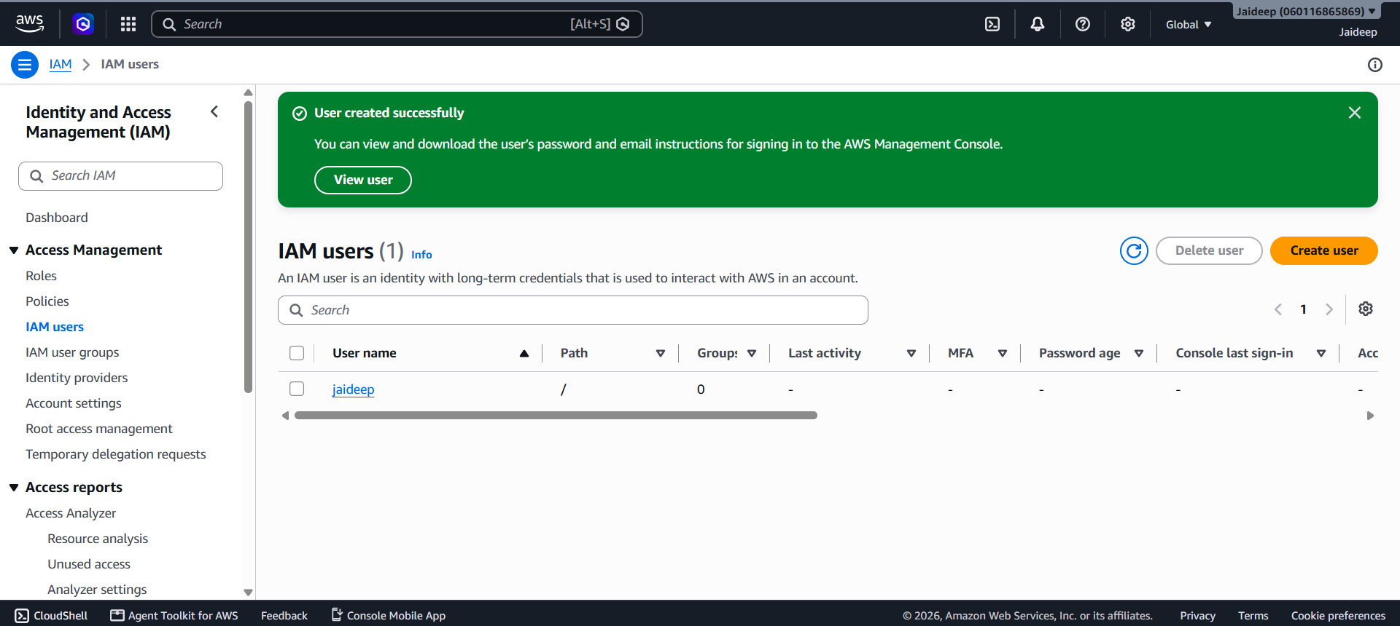
- Open the Security credentials tab.

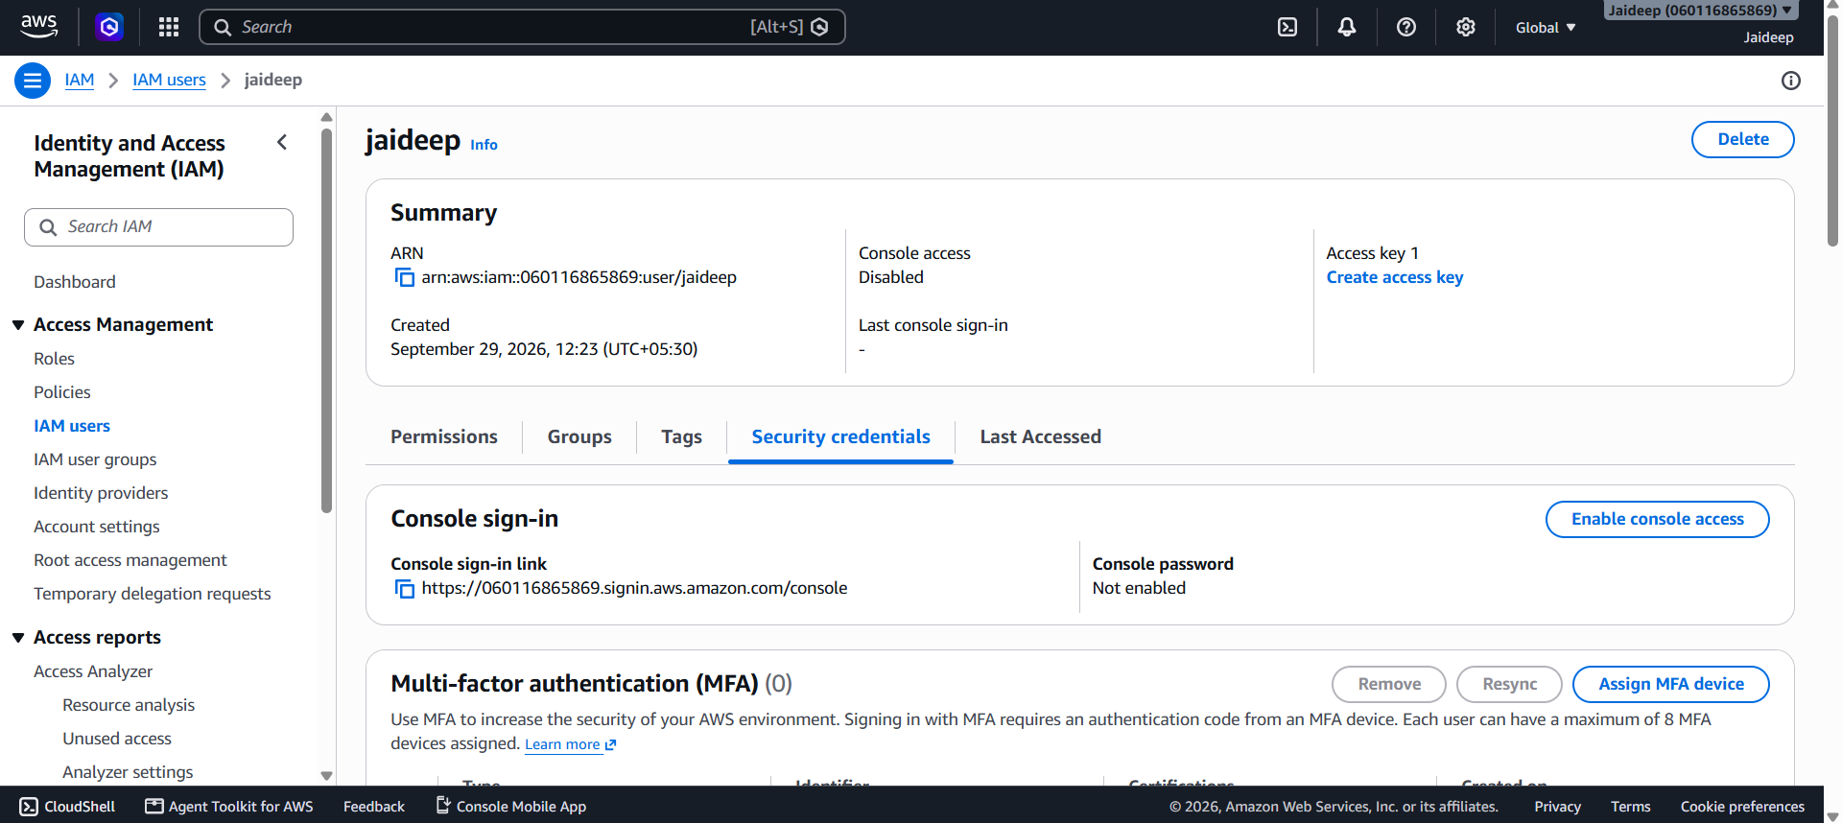
- Under Access keys, select Create access key.

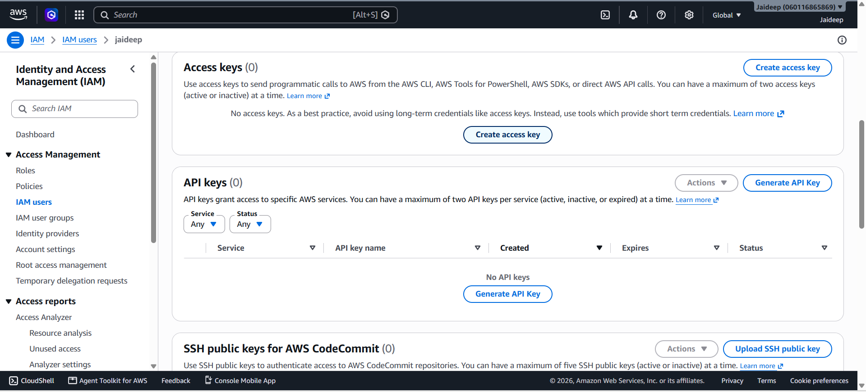
- Select Command Line Interface (CLI) as the intended use, if prompted.

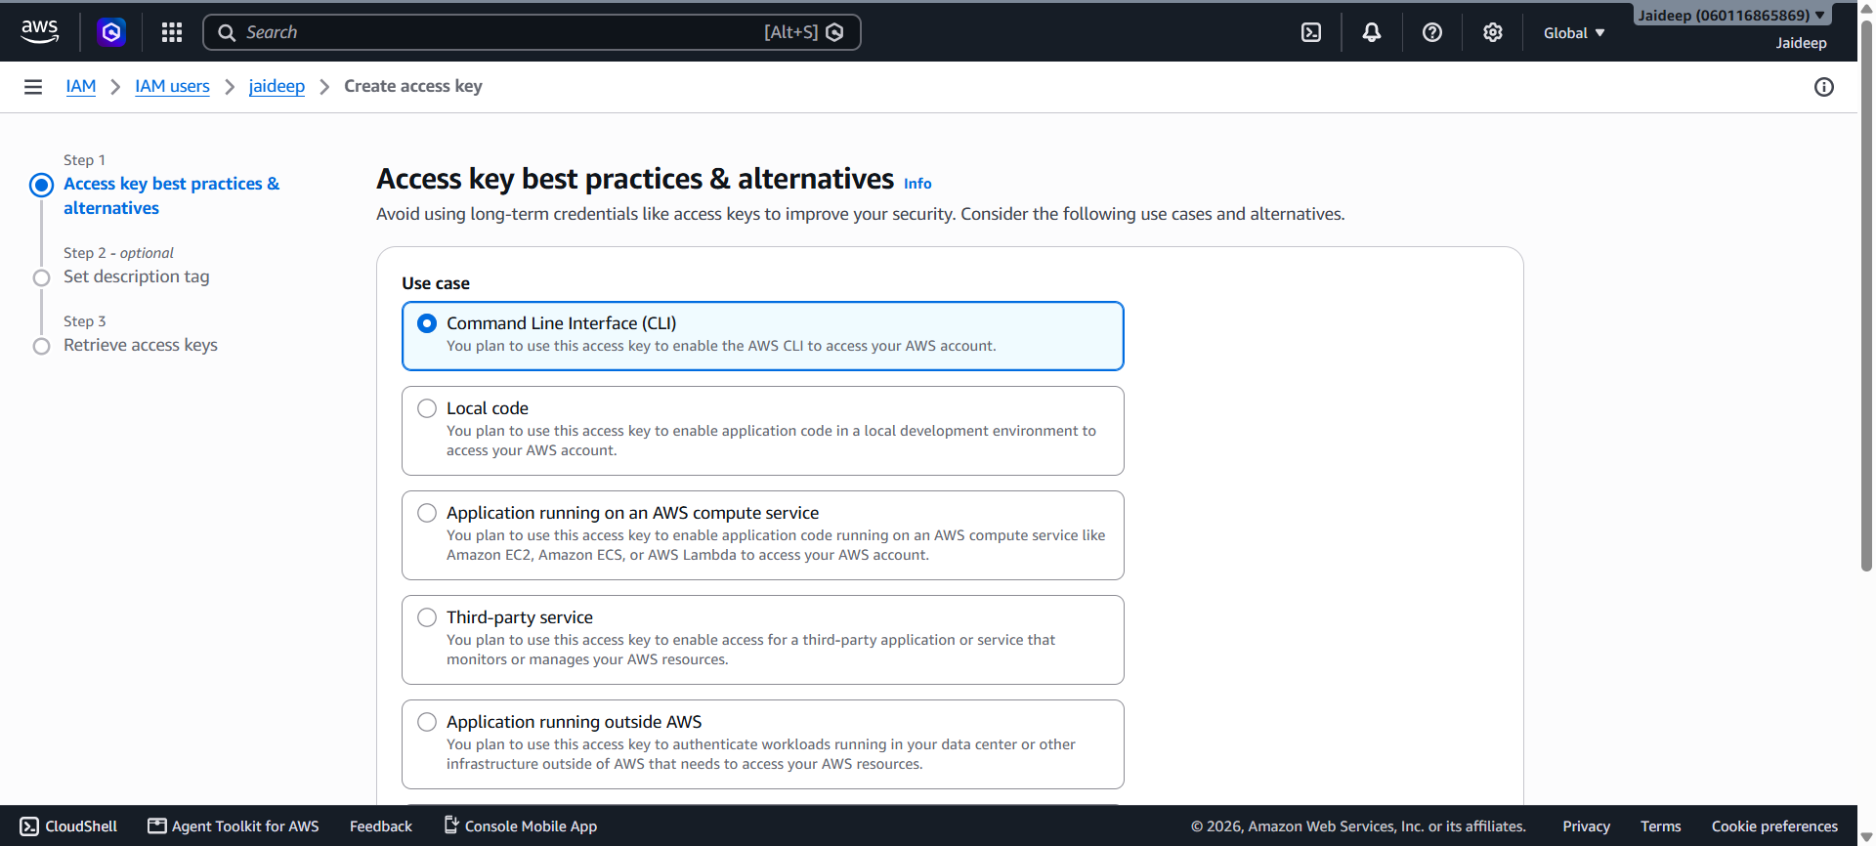

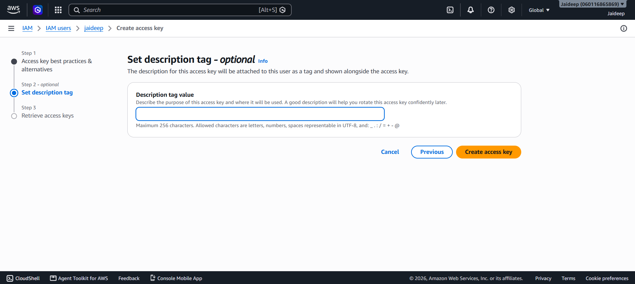
- Create the access key and securely save the displayed:
  - Access Key ID
  - Secret Access Key

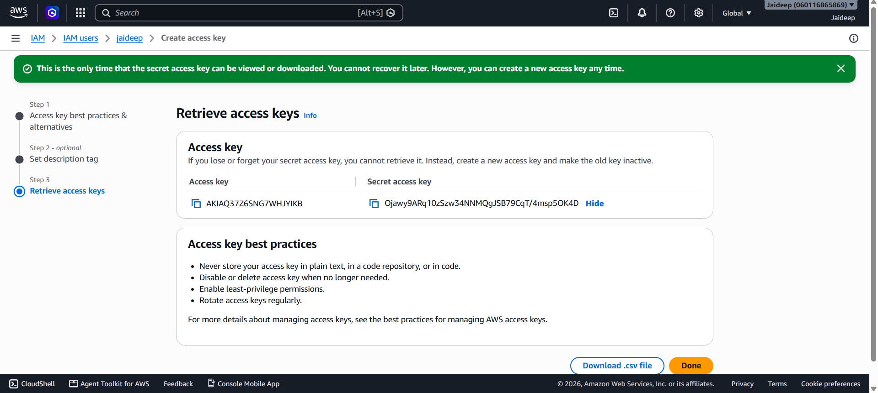
2. Configure AWS CLI
- Open Command Prompt/PowerShell or Terminal.
- Run:
aws configure
- Enter the requested information:
AWS Access Key ID: <your-access-key-id>
AWS Secret Access Key: <your-secret-access-key>
Default region name: ap-south-1
Default output format: json
Use your own AWS credentials. Do not include access keys or secret keys in the practical report.
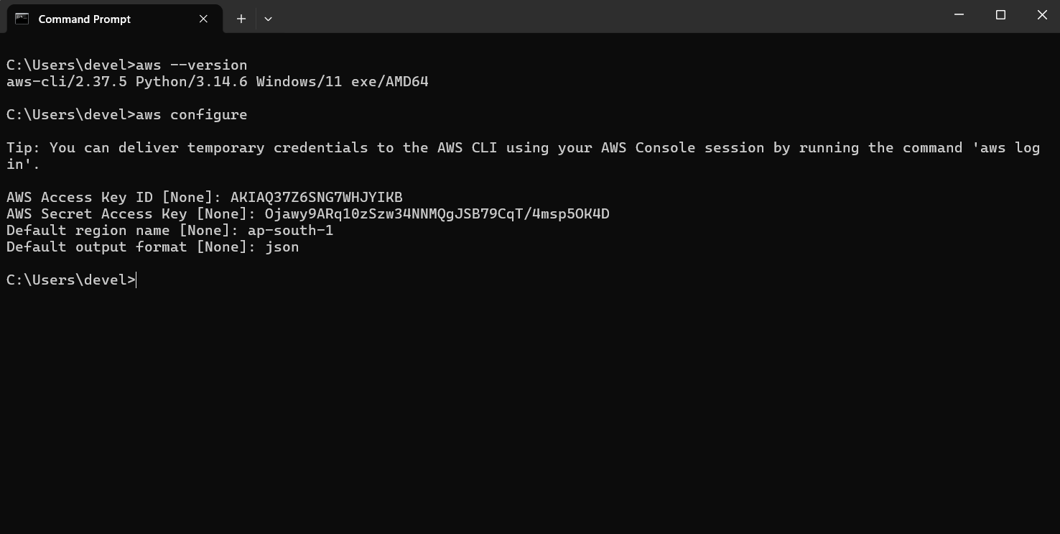
- Verify the configuration by running:
aws sts get-caller-identity
This displays information about the AWS account and identity associated with the configured CLI credentials.
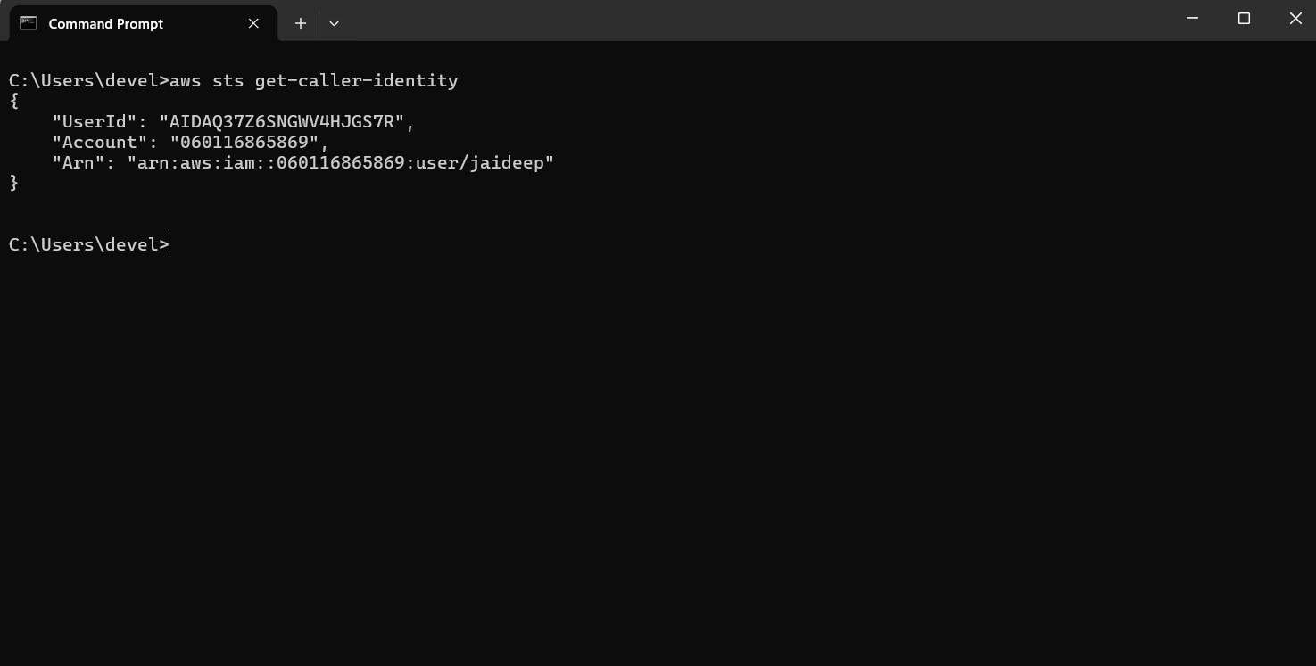
3. Create an S3 Bucket
S3 bucket names must be globally unique. Replace <unique-bucket-name> with a name that is not already used.
For the Mumbai region:
aws s3api create-bucket --bucket <unique-bucket-name> --region ap-south-1 --create-bucket-configuration LocationConstraint=ap-south-1
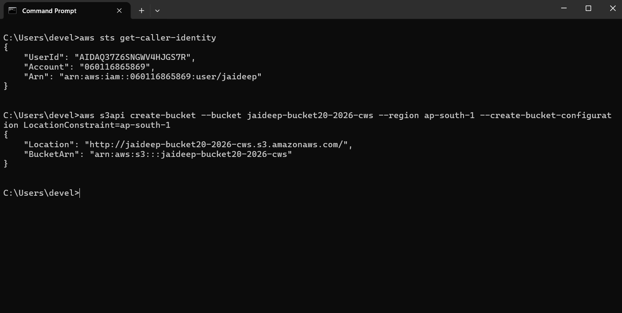The command creates an S3 bucket in the specified AWS Region.
4. List S3 Buckets
To display all S3 buckets associated with the AWS account, run:
aws s3 ls
The newly created bucket should appear in the list.
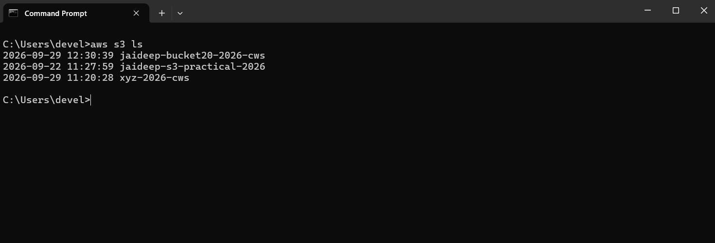
5. Create a Sample File
Create a simple text file for testing the upload operation.
For example, create a file named:
sample.txt
Add some text such as:
This file is created for AWS S3 CLI practical.
Save the file in the current working directory.
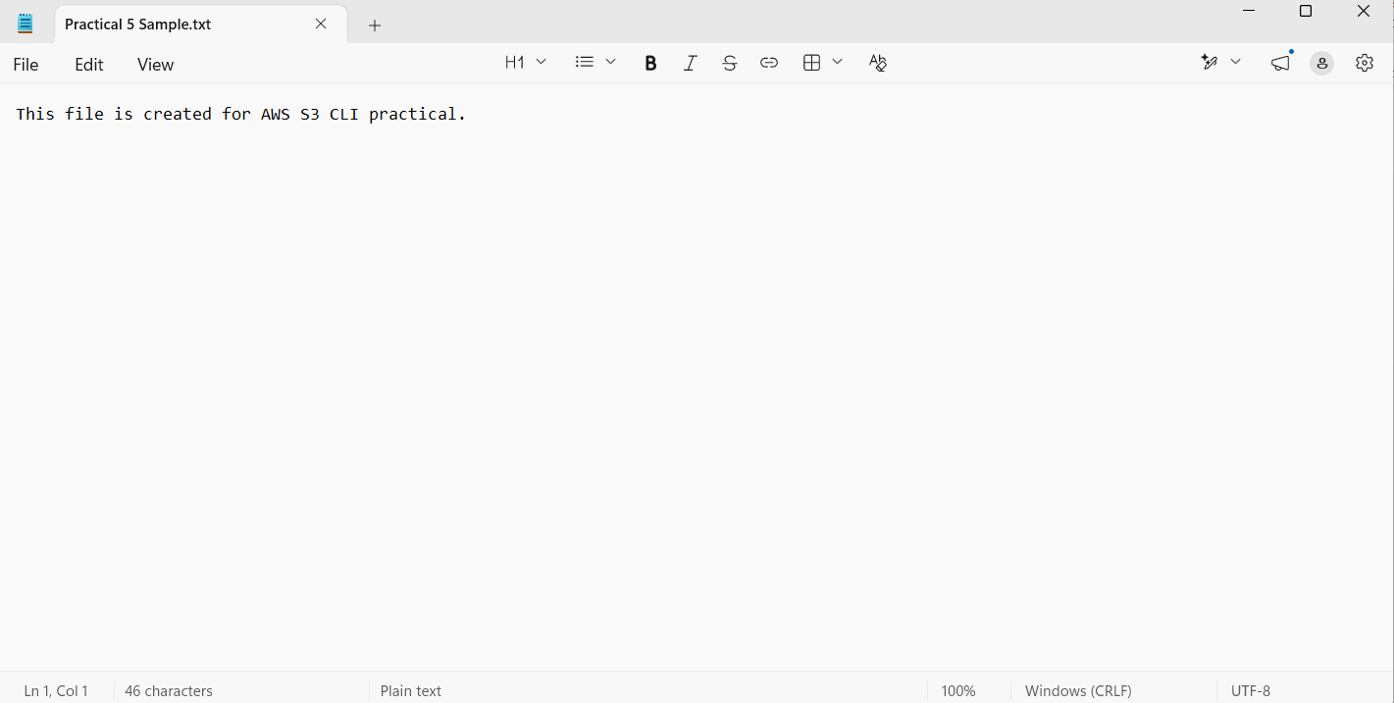
6. Upload an Object to the S3 Bucket
Use the following command:
aws s3 cp sample.txt s3://<unique-bucket-name>/
Example:
aws s3 cp sample.txt s3://my-cli-practical-2026-unique/
The cp command copies the local file to the specified S3 bucket.
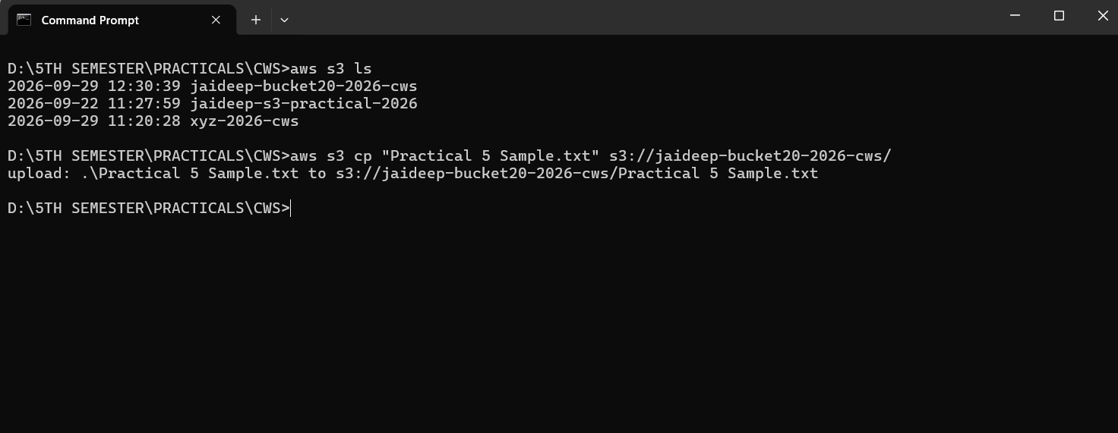
7. List Objects in the Bucket
To verify that the file was uploaded:
aws s3 ls s3://<unique-bucket-name>/
The output should display sample.txt.
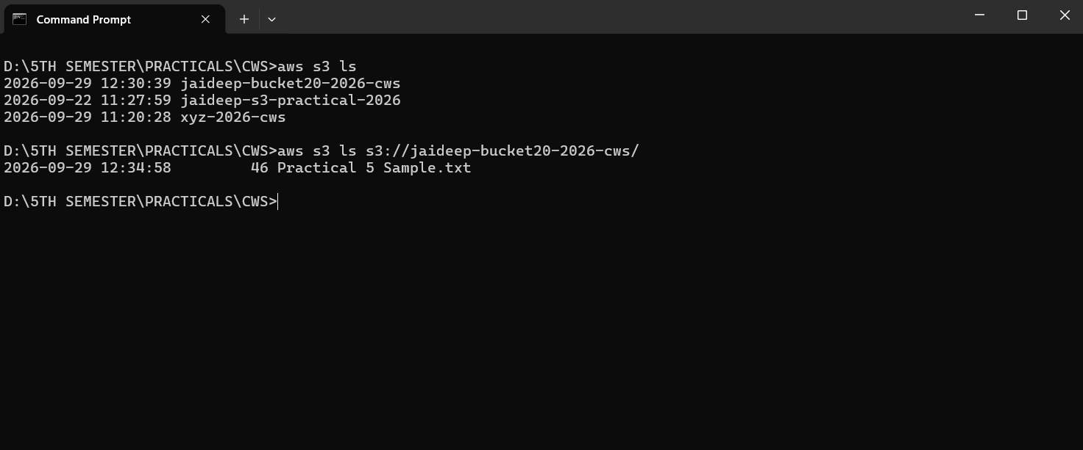
8. Download an Object
To demonstrate another S3 object operation, the uploaded file can be downloaded:
aws s3 cp s3://<unique-bucket-name>/sample.txt downloaded-sample.txt
This downloads the S3 object to the local computer.
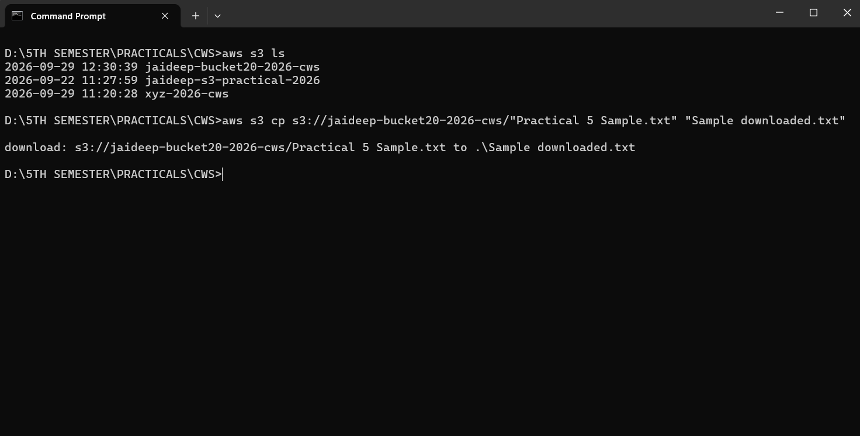
9. Delete an Object
To delete the uploaded object from the bucket:
aws s3 rm s3://<unique-bucket-name>/sample.txt
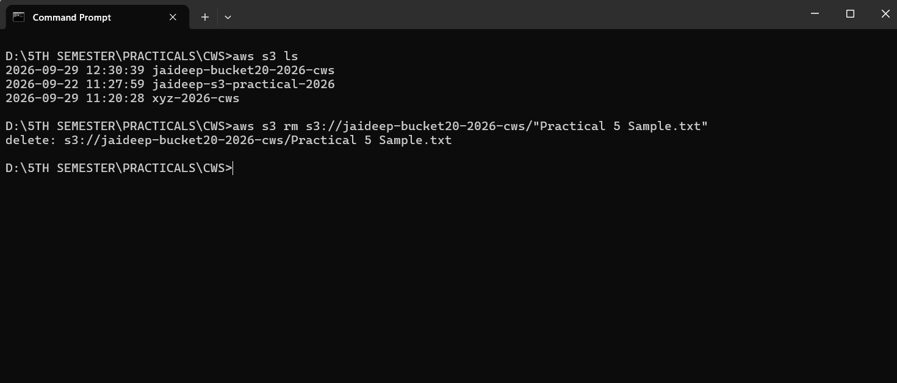
Verify that the object has been removed:
aws s3 ls s3://<unique-bucket-name>/
The object should no longer be listed.
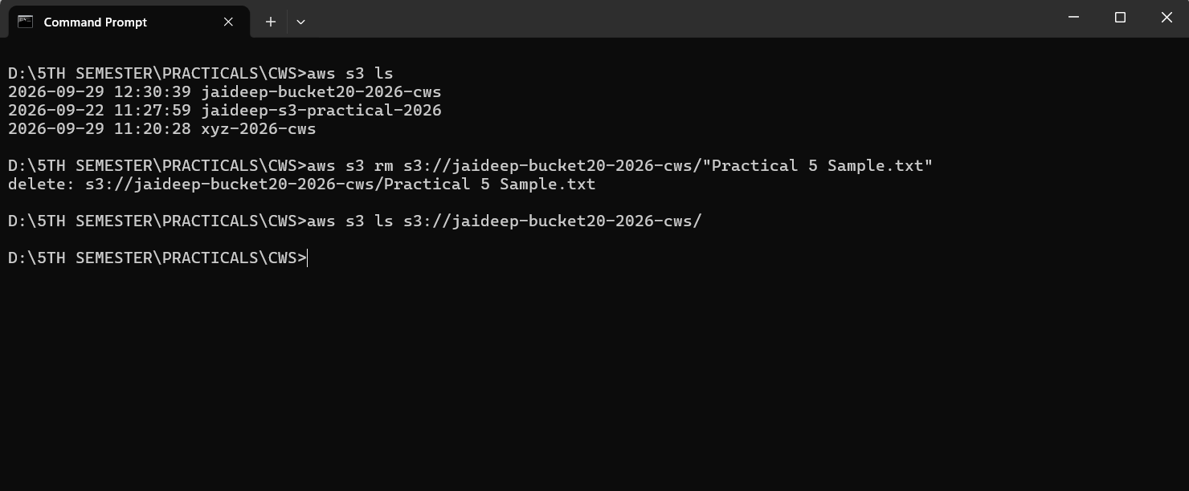
10. Delete the S3 Bucket
After deleting all objects from the bucket, delete the bucket using:
aws s3 rb s3://<unique-bucket-name>
Alternatively:
aws s3api delete-bucket --bucket <unique-bucket-name> --region ap-south-1
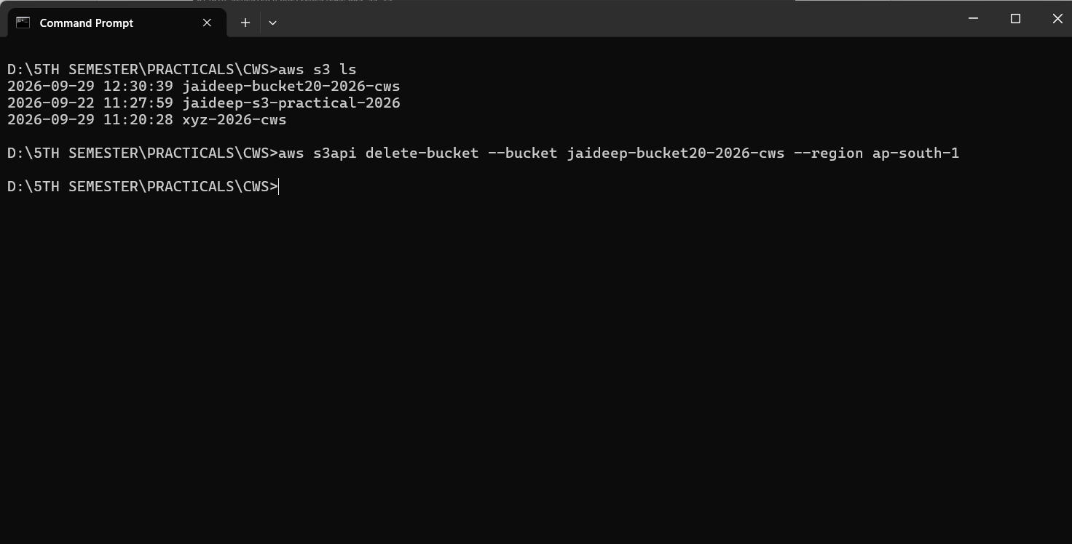
Verify the bucket deletion:
aws s3 ls
The deleted bucket should no longer appear in the list.
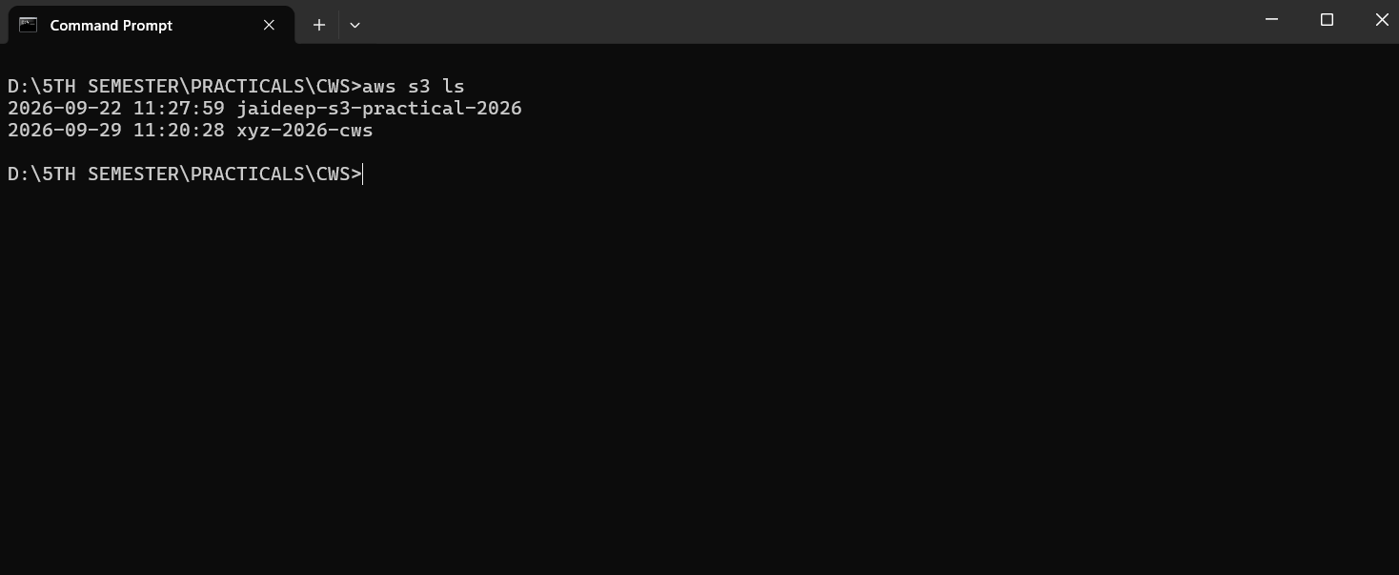
Command Summary
Operation | AWS CLI Command
Check AWS CLI | aws --version
Configure CLI | aws configure
Verify identity | aws sts get-caller-identity
Create bucket | aws s3api create-bucket ...
List buckets | aws s3 ls
Upload object | aws s3 cp sample.txt s3://<bucket>/
List objects | aws s3 ls s3://<bucket>/
Download object | aws s3 cp s3://<bucket>/sample.txt downloaded-sample.txt
Delete object | aws s3 rm s3://<bucket>/sample.txt
Delete bucket | aws s3 rb s3://<bucket>
Result
The AWS CLI was successfully installed and configured. S3 operations including bucket creation, bucket listing, object upload, object listing, object download, object deletion, and bucket deletion were performed successfully through command-line commands.

